**SUPPLEMENTARY FIGURES:**



*Fig. S1: Climate data comparisons for large (SG1 vs SG2; A-C) and medium (top vs bottom of SG1, D-F) scales. Weather measurements were collected simultaneously at the two compared sites, showing differences in temperature (A, D) and relative humidity (B, E) of the locations. Colors denote the time (hours after midnight) of data collection for each point. The number of hours in the day when halites experienced deliquescence was estimated from the time when the relative humidity was above 75% (C, F). Paired weather data was collected hourly from 2018-03-01 to 2018-05-01 with a HOBO probe located 1m above the ground.*

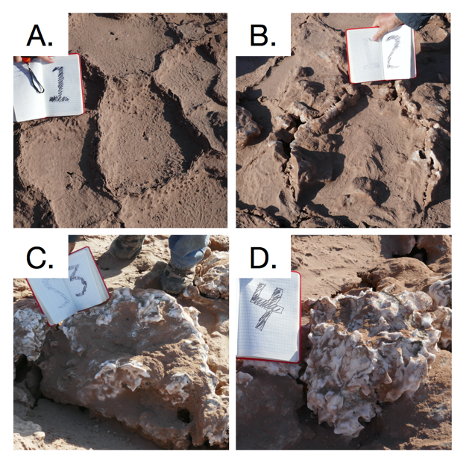

*Fig S2: Example photos of the stages of halite nodule development: a flat polygon (A), a rising polygon (B), a halite nodule (C), a fully mature halite nodule (D). 20cm notebook shown for scale.*



*Fig. S3: Distribution of halite nodules across the surface of different locations in Salar Grande. The relative distribution percentage was estimated from 6 randomized 100m transects, along salt formations were classified according to stages of nodule formation, from a flat polygon to a mature halite nodule.*



Fig S4: Cell count density within the top, middle, and bottom samples in the different halite slices. Cell counts were estimated by counting nuclei per field of view with an automated cell-counting pipeline. Halites are denoted H1-H6, and slices within each halite are denoted A-C. Each point represents a technical replicate from a single field of view.



Fig. S5: The average cell density of each biological sample, standardized to the maximum value within each slice (x-axis). Black corresponds to the position with the highest cell count in that slice.

**

*Fig. S6: PCoA of the Weighted Unifrac dissimilarity matrix of 16S rDNA amplicon sequences, comparing community compositions in samples collected from different positions within the halite nodules. The scatterplot projections show the first and second principal components, coloring the samples by A) the samples’ relative vertical position within the halites, B) the halite nodule, and C) the vertical slice of the samples’ (each slice is labeled randomly with a color-shape combination).*

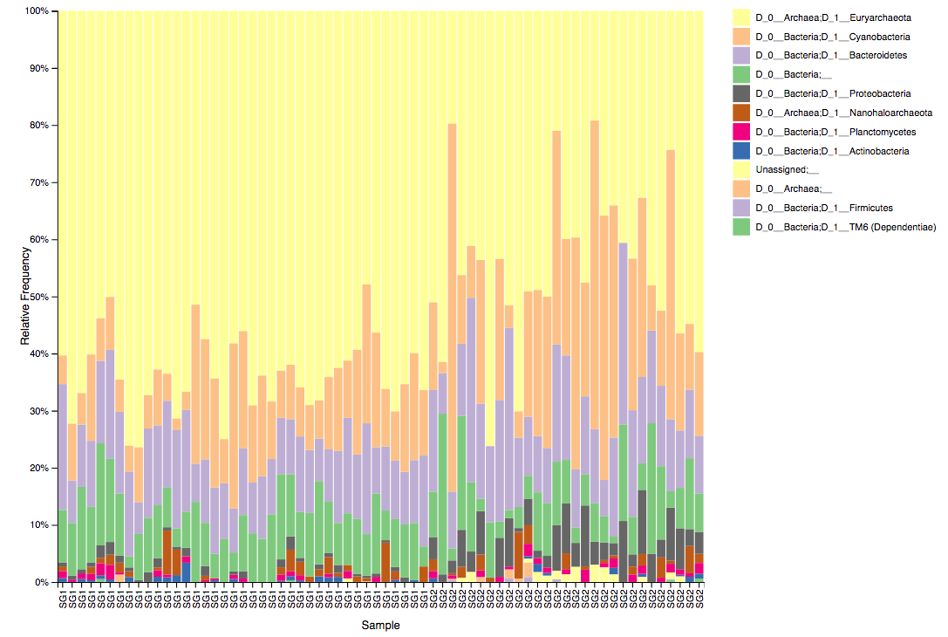

*Fig. S7: Relative taxonomy composition of SG1 and SG2 locations at the D3 (phylum level). Note that chloroplast sequences are included under the “Cyanobacteria” phylum in Qiime2.*



*Fig. S8: Relative taxonomy composition of halite communities at the top and bottom of the SG1 hill in 2016 at the phylum level. Note that chloroplast sequences are included under the “Cyanobacteria” phylum in Qiime2.*



*Fig. S9: Relative abundance of major halite microbiome phyla inside the halite nodules at the top, middle and bottom positions within each sampled nodule slice. The relative abundances were standardized to the average abundance of that phyla in each slice. Chlorophyta (chloroplast) sequences were only detected at low abundances is a few samples, and are not shown here. Bars above each phyla represent Student’s t-test significance, and the stars denote the associated p-value (***: pval<0.0001, **: pval<0.001, *: pval<0.01).*

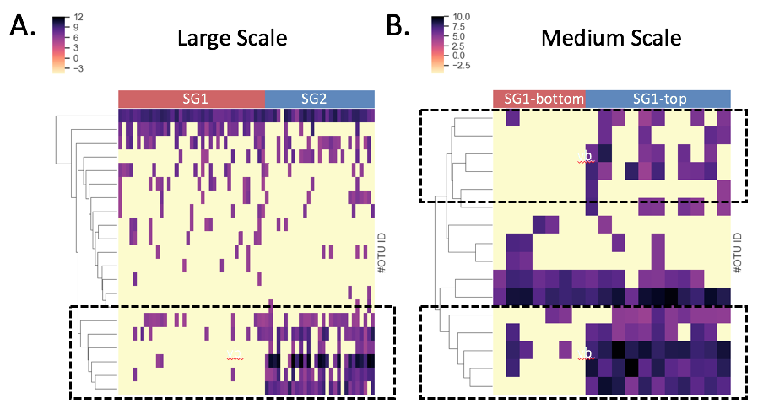

Fig. S10: Heat map comparing different in the relative abundance of *Proteobacteria* OTUs (y-axis) in samples (x-axis) from A) SG1 and SG2, and B) top and bottom of SG1.